Committing to meets:
You should receive a meet invite email. Go to link in email. Click the small menu and View Meets. Through the Events Tab on the Home Screen, input your status for EACH meet by the deadline - Accept or Decline. Then save. That is it! If you do not receive an email please let the coaches know by the Wednesday before the meet your child will swim. They can manually input them.
IF you have NOT Committed to a meet by the deadline, your swimmer cannot swim!
- If you are Committed to a meet, your swimmer must be at the location and CHECKED IN by 7 am. Home meet check-in is 6:30 am
- Scratches (swimmer is removed from swimming) will begin promptly at 7 a.m. by the coaches.
  - Scratches due to illness must be notified by 7 a.m. via text to XXX.
  - Once a swimmer is scratched they will not be allowed to swim under any circumstances.
- Plan for traffic and unanticipated events accordingly.
- Swimmers and families should be at the meet location by 630 a.m.
Volunteers:
One volunteer from each family that is swimming is mandatory and they should check in with the designated volunteer coordinator immediately after checking in your child. The volunteer coordinator will let you know your volunteer responsibilities for the day's events.
You will be assigned a position AM/PM. If 1 person in your family cannot work the position YOU are responsible for finding a replacement. Remember High Schoolers can earn volunteer hours if they work. Please let the Volunteer Coordinator Alicia Higgins know ASAP of changes: 251-300-9349
Failure to show:
Failure to show can result in their entire relay team being scratched.
- Failure to show for a Committed meet may result in penalties for the swimmer - such as 1 meet suspension from relays - at the discretion of the coach.
- Chronic failure to show for a Committed meet my result in more serious penalties at the discretion of the coach and board.

Questions about Meets

Where are meets held?

Most meets are held at neighborhood and high school pools in the Clear Lake area.

When are the meets held and how long do they last?

Every Saturday in June and lasting through July 9. Plan to stay for the whole meet-espeically home meets! It takes a team to run the meets!

Time to be at the meet

Swimmers need to report to the pool by 6:45 a.m. to check-in and warm-up. Home Meets arrive by 6:30 AM! Meets start at 8:00 a.m. and generally last until 1:00 p.m. depending on the number of entries.

Order of events

There are 80 separate events that begin with the individual medley, followed by the medley relay, freestyle, backstroke, breaststroke, butterfly and freestyle relay.

What if my child has to leave a meet early?

Please notify the coach of any absence or early departure. Please remember that if your child swims on a relay, his/her absence will affect 3 other swimmers. Sometimes your child may be placed in an individual or relay event as a replacement swimmer during the meet.

Please check with the Clerk of Course and the coaches before actually leaving.

What is a DQ?

DQ stands for disqualification. Swimmers are judged according to the USA Swimming Rules & Regulations for competition. Swimmers are most often disqualified for executing a start, stroke, turn or finish illegally, particularly in breaststroke and butterfly. They may also be disqualified for early takeoff in relays. It is important to remember that the meet Referee has the ability to disqualify individual competitors for poor sportsmanship and conduct as well.

Do not approach any official regarding a disqualification. By CCSL rule only an official league representative may do so. Disregarding this rule could cause the team to incur sanctions or prompt your removal from the competition. Please represent yourself, your swimmer, and the team with respect of officials as well as all other meet volunteers.

Who determines which swimmers swim on the relay teams?

The coaches determine who swims on which relay team. They will often rely on statistics the team keeps on individual competitive performances when setting up relays.

STEPS TO ACCEPT/DECLINE MEETS:

Receive an invite email from e no-reply@active.com Please add this to your address books.

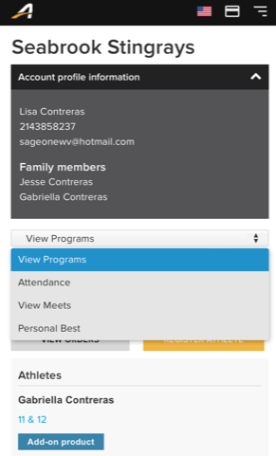

Choose View Programs

The next page will be an accept/decline. Then SAVE and you are done!

